**Program 2**

|  |
| --- |
| importjava.io.*; |
|  |
|  | import java.util.*; |
|  | class Account |
|  | { |
|  | double balance; |
|  | Account() |
|  | { |
|  | balance = 0; |
|  | } |
|  | Account(double sum) |
|  | { |
|  | balance = sum; |
|  | } |
|  | double add(double sum) |
|  | { |
|  | balance += sum; |
|  | return sum; |
|  | } |
|  | double withdraw(double sum) |
|  | { |
|  | if (sum > balance) { |
|  | balance -= 5; |
|  | return -5; |
|  | } |
|  | else { |
|  | this.balance -= sum; |
|  | return balance; // Notice: always >= 0 (never < 0) |
|  | } |
|  | } |
|  | double inquire() |
|  | { |
|  | return balance; |
|  | } |
|  | double interest (double rate) |
|  | { |
|  | return rate * balance; |
|  | } |
|  | } |
|  | class bank1 |
|  | { |
|  | public static void main(String args[]) |
|  | { |
|  | try |
|  | { |
|  | Scanner s=new Scanner(System.in); |
|  |  |
|  | System.out.println("Enter account holder name:"); |
|  | String s1=s.next(); |
|  | System.out.println("Enter account type:"); |
|  | String s2=s.next(); |
|  | int b=0; |
|  | System.out.println("Enter the initial value"); |
|  |  |
|  | b=s.nextInt(); |
|  | Account A; |
|  | if (b==0){ |
|  | A = new Account(); |
|  | } |
|  | else{ |
|  | A = new Account(b); |
|  | } |
|  |  |
|  | System.out.println("Enter the amount to withdraw"); |
|  | b=s.nextInt(); |
|  |  |
|  | double d = A.withdraw(b); |
|  | System.out.println("Account holder name:"+s1); |
|  | System.out.println("Account type:"+s2); |
|  | if (d == -5) { |
|  | System.out.println("Penaly RS. -5 is charged since insufficient balance"); |
|  | System.out.println("Currrent balance" + A.inquire()); |
|  | } |
|  | else{ |
|  | System.out.println("Now balance after withdraw of"+ A.inquire() + "is" + d); |
|  | } |
|  | System.out.println("Interest for current balance" + A.inquire() + " is " + |
|  | A.interest(0.006)); |
|  | } |
|  | catch(Exception e) |
|  | { |
|  | System.out.println("Due to character exception"); |
|  | } |
|  | } |
|  | } |

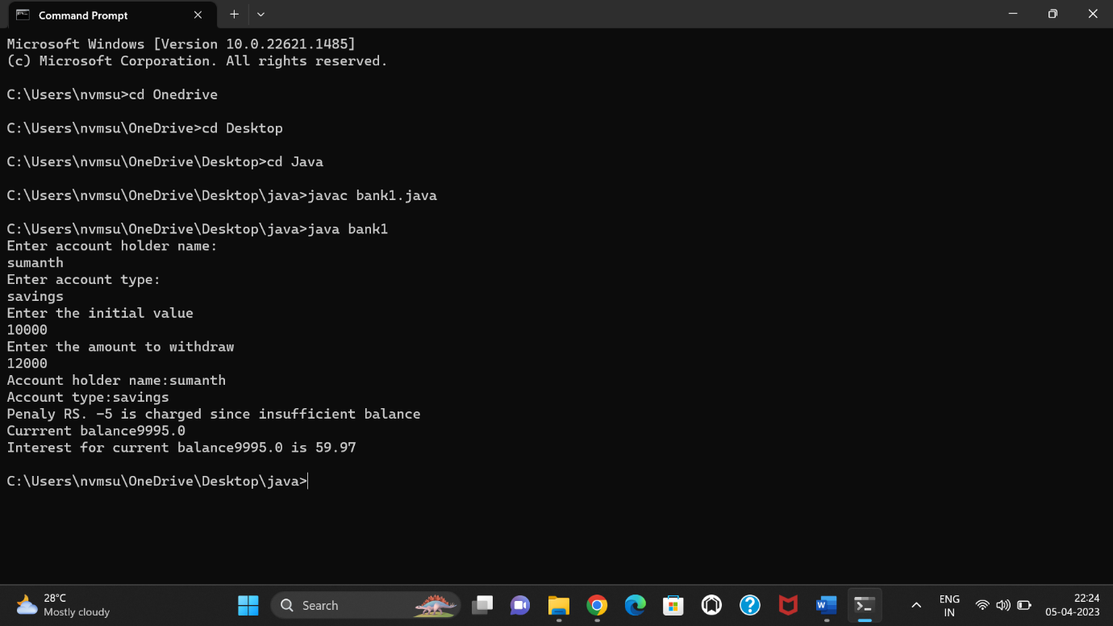

**Program 3**

**public class ImplementStrStr {**

**public int strStr(String haystack, String needle) {**

**// Base condition**

**if (haystack == null || needle == null) {**

**return -1;**

**}**

**// Special case**

**if (haystack.equals(needle)) {**

**return 0;**

**}**

**// length of the needle**

**int needleLength = needle.length();**

**// Loop through the haystack and slide the window**

**for (int i = 0; i < haystack.length() - needleLength + 1; i++) {**

**// Check if the substring equals to the needle**

**if (haystack.substring(i, i + needleLength).equals(needle)) {**

**return i;**

**}**

**}**

**return -1;**

**}**

**}**

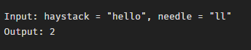

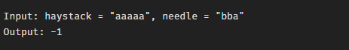

**Program 4**

**import java.io.*;**

**import java.util.*;**

**public class lastw {**

**public static void main(String[] args){**

**int len = 0;**

**String x;**

**Scanner sc=new Scanner(System.in);**

**System.out.println("Enter the string :");**

**x=sc.nextLine();**

**String a= x.trim();**

**for (int i = 0; i < x.length(); i++) {**

**if (x.charAt(i) == ' ')**

**len = 0;**

**else**

**len++;**

**}**

**System.out.println("The length of last word is "**

**+ len);**

**}**

**}**

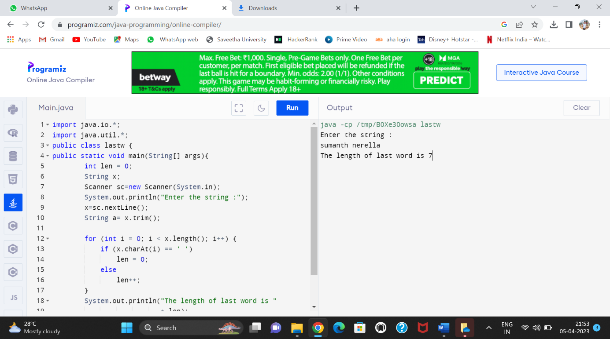

**Program 5**

**import java.io.*;**

**import java.util.*;**

**class factor**

**{**

**public static void main(String args[])**

**{**

**try**

**{**

**Scanner sc=new Scanner(System.in);**

**int count=0,n,i;**

**System.out.println("Enter the number:");**

**n=sc.nextInt();**

**if(n<=0)**

**{**

**System.out.println("Enter valid number");**

**}**

**else**

**{**

**for(i=1;i<=n;i++)**

**{**

**if(n%i==0)**

**{**

**count++;**

**}**

**}**

**System.out.println("The number of factors:"+count);**

**}**

**}**

**catch(Exception e)**

**{**

**System.out.println("Enter only numbers");**

**}**

**}**

**}**

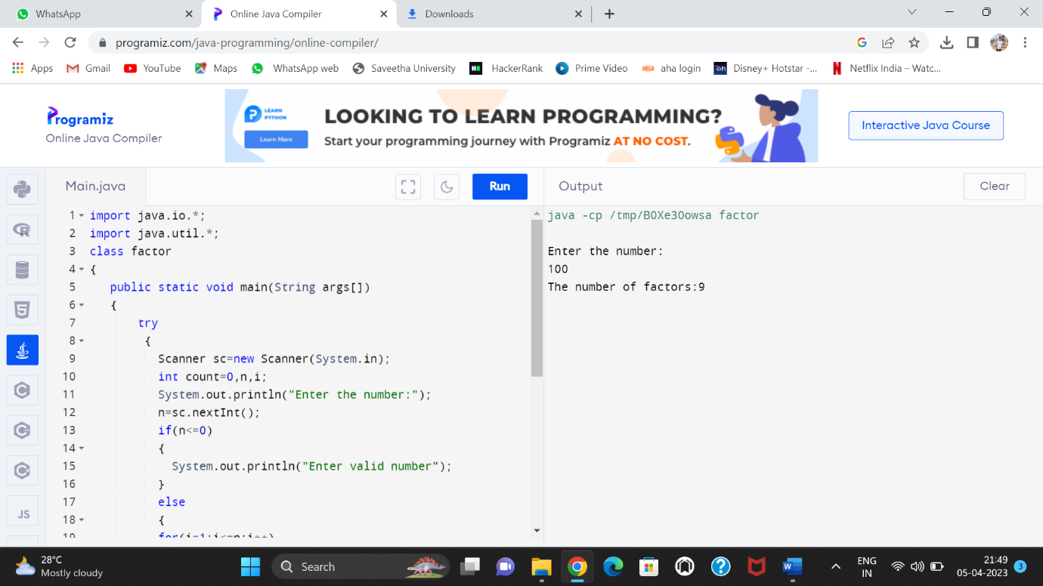

**Program 1 :**

**6)**

**public class SubstringExample{**

**public static void main(String args[]){**

**String s1="saveetha";**

**System.out.println(s1.substring(2,4));**

**}}**

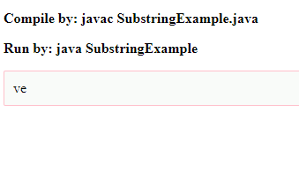

**7)**

**public class StringTrimExample{**

**public static void main(String args[]){**

**String s1=" hello student ";**

**System.out.println(s1+"Welcome");**

**System.out.println(s1.trim()+"Welcome");**

**}}**

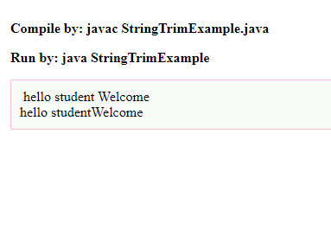

**8)**

**public class LengthExample{**

**public static void main(String args[]){**

**String s1="Saveetha";**

**String s2="Java";**

**System.out.println("string length is: "+s1.length());**

**System.out.println("string length is: "+s2.length());**

**}}**

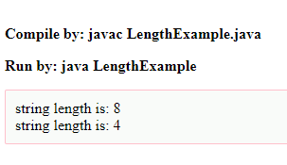

**9)**

String txt = "Hello World";

System.out.println(txt.toUpperCase());

System.out.println(txt.toLowerCase());

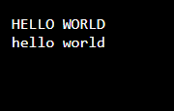

**10)**

**class Teststringcomparison1{**

**public static void main(String args[]){**

**String s1="sumanth";**

**String s2="sumanth";**

**String s3=new String("sumanth");**

**String s4="nerella";**

**System.out.println(s1.equals(s2));**

**System.out.println(s1.equals(s3));**

**System.out.println(s1.equals(s4));**

**}**

**}**

